GMS Data Pruning and De-identification
Design Document


Author: Innovacx
Creation Date: Jul 04, 2018
Last Update: Jan 03, 2019
Title, Subject, Last Updated Date, Reference Number , and version are marked by a Word bookmark so that they can be easily reproduced in the header and footer of documents. When you change any of these values, be careful not to accidentally delete the bookmark. You can make bookmarks visible by selecting Tools->Options…View and checking the Bookmarks option in the Show region.
Title, Subject, Last Updated Date, Reference Number , and version are marked by a Word bookmark so that they can be easily reproduced in the header and footer of documents. When you change any of these values, be careful not to accidentally delete the bookmark. You can make bookmarks visible by selecting Tools->Options…View and checking the Bookmarks option in the Show region.
To add additional approval lines, press [Tab] from the last cell in the table above.

Approvers:
Maroun Azzi
Vivek Jaiswal

You can delete any elements of this cover page that you do not need for i ur document.

Document of Control

Change Control
2
Date | Author | Version | Reference of changes
4th June, 18 | Innovacx | 0.1 | 1st Draft
12th June | Innovacx | 0.2 | 2nd Draft
18th June | Innovacx | 0.3 | 3rd Draft
21st June | Innovacx | 0.4 | Incorporated Feedback  Added more details
22nd June | Innovacx | 0.5 | Incorporated Feedback  Added more details
27th June | Innovacx | 0.6 | Incorporated Feedback  Added more details
28th June | Innovacx | 0.7 | Incorporated Feedback  Added more details
4th July | Innovacx | 0.8 | Incorporated Feedback  Added more details
5th July | Innovacx | 0.9 | Incorporated Feedback  Added more details
4th Jan | Innovacx | 1.0 | Incorporated Enhancements details

Contents
1 Document of Control ii
1.1 Change Control ii
2. Functional Design for GMS Data Pruning and De-identification 4
2.1. GMS Data Pruning 4
2.1.1 Requirement Summary 4
2.1.2 Proposed Solution 5
2.2. GMS Data Masking 13
2.2.1 Requirement Summary 13
2.2.2 Proposed Solution 13
2.2 Truncate Interface Table 20
2.3 Assumptions 20
3. Jenkins Pipeline 21
3.1 Table of Steps in Jenkins 21
4. FilePath 22
4.1 Table of Files and File path 22
5.1 Open Issues 23
5.2 Closed Issues 23
6. Appendix 24
6.1 Appendix 1 24
6.2 Appendix 2 24

Functional Design for GMS Data Pruning and De-identification

Provide a textual description of the process that is executed in response to each event, along with an identification of the main inputs and outputs of the process. Also describes the business issues that are associated with the business process, and that may be solved through the future processes.
Repeat this section for each business area.
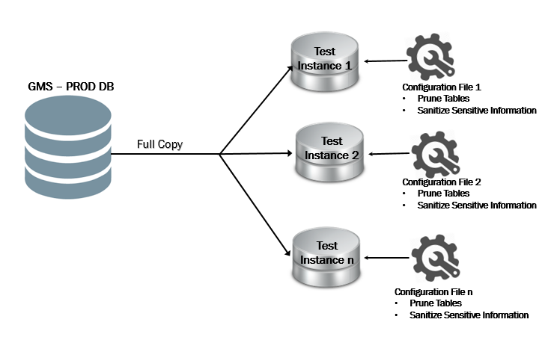

Image 1: GMS Data Purging and Data Masking high-level flow diagram

GMS Data Pruning

Requirement Summary
NRMA’s production Siebel instance has huge data as it retains data from the last 7 years.
The data on production instance includes Siebel entities like Order, Order Line, Payments, Assets and needs purging when the same data is moved to test instance. NRMA wishes to build an automated process which retains only delta of production database by dynamically passing the criteria in target TEST database.
Also, NRMA has an intolerable risk associated with how the current data copy is performed, and in line with increasing Data Governance controls, NRMA is looking to ensure that member and customer data is not present in non-production environments.
As part of this project, automated processes will be built to perform data purging and de-identification operations on the target test instance after copying production data. These automated processes will leverage Siebel EIM framework, Shell scripts, PL/SQL scripts and Jenkins to achieve robust data purging and masking operations.

Proposed Solution

Innovacx proposes below approach to resolve issue while copying high volume data in Siebel Production database: -

2.1.2.1 Clone Prod DB
- Since we cannot prune or mask the data in the production, as initial setup, we copy the entire Production instance to target Test instance.
- This step will be performed using the current approach to copy the production data to test instance. No additional tool or script is needed.
- All further activities will be performed on the “Target Test Instance”.

2.1.2.2 Prune Tables
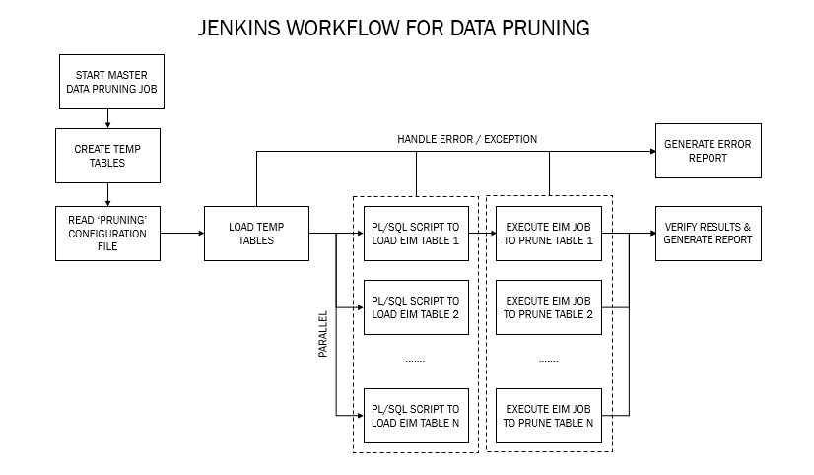

Pre Pruning Setup
- Create a New schema/New User – ‘DATA_PRUNING_USER’ in the target test DB.
DBA team should execute below script–
CREATE USER DATA_PRUNING_USER IDENTIFIED BY <password>;
GRANT SSE_ROLE TO DATA_PRUNING_USER;
GRANT RESOURCE to DATA_PRUNING_USER;
- Create a new Temp table – ‘DATA_PRUNING_TABLE’ on above schema.
    - This table will have ‘columns’ to store Member Number, ID’s for the entities like Contact, Account etc required to perform deletion.
    - DDL script to create a new table will be scheduled via Jenkins.
- Create a new table to store PROD details used in pruning process – ‘DATA_RETENTION_PROD_TAB’ on ‘DATA_PRUNING_USER’ schema.
    - This table will have ‘columns’ to store Product Part Number and Member Retention percentage (95%, 90% etc), Asset Start Date, and Asset End Date against that product.
    - DDL script to create a new table will be scheduled via Jenkins.
- Jenkins URL should be provided to schedule PL/SQL and EIM jobs on the TEST Database Instance.
- The overall performance of EIM is largely dependent on the overall performance of the database server. To achieve optimal database server performance, it is critical that the tables and indexes in the database be arranged across available disk devices in a manner that evenly distributes the processing load.
- Disable the database triggers.
- Ensure that all components except ‘Enterprise Integration Manager’ are shut down before executing the EIM job.
- Ensure DBA tuning is performed after first dry run (in UAT).

Pruning Criteria
As of today, NRMA wants to retain about 5% of the records for members and its child entities which belongs to Classic Care, based on year and tenure adjustment, rest all will qualify for pruning(95% of CC Data Only). The below attached table contains tenure-wise data which belongs to Classic Care members. Other kind of member/product combo do not present significant volume.
These criteria can be changed in future to use different product and different reten tion percentage. Solution will be built in a way as to accommodate product name and retention percentage dynamically.
Apart from deleting the master entity (Contact) and its corresponding child entities, NRMA wants to clear the log tables which constitute high data volume.
The pruning Criteria table is shown here in Pruning Criteria.xlsx
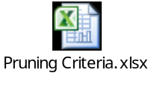

B.1 Member Exclusion Scenarios
- we need to exclude the Members who are having CC product with combination of other products except “MEM”, “PROMCC” products.
- Exclude the all household members and child members who are having CC product.
- Exclude the all Supplier data.
- Exclude the all Branch data.

‘Configuration file’ to pass Criteria
NRMA wishes to build a Data Pruning job that can be executed on any target test DB instance by passing dynamic criteria values. In order to achieve this, solution includes ‘Configuration File’ that will be passed as an input file while executing the PL/SQL scripts.
This configuration file will be mostly used to store product and member pruning percentage information.
In this ‘Configuration File’, user can specify the PART_NUM and respective PRUNING_PERCENT and its criteria which needs to be considered while pruning/truncating the tables.
Sample pruning configuration file format is attached below -

Data_Pruning_Configuration_file.txt

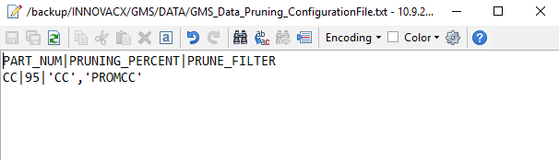

Identify & Insert Pruning data
As a first step to start the pruning process, user should update the configuration file with product’s part number, member pruning percentage, and prune filter (it is a “|” separated value).
To load data in to the table - ‘NRMA_DATA_PRUNE_PROD_TAB’, Script will be authored to read configuration file and insert the data.
Once temporary product table gets updated successfully, PL/SQL procedure would be executed to insert 95% data which needs to be pruned into the temp table – NRMA_DATA_PRUNE_TABLE’.
Once done, subsequent PL/SQL scripts to insert data into the EIM table for pruning will check if record reference exists in the ‘NRMA_DATA_PRUNE_TABLE’ temp table. If exists, record will be considered for pruning.
As the member shouldn’t be Pruned If it is part of another Product, while filtering we Shouldn’t consider some Products as most of it present in both products.
For Example, If we consider Pruning with PART_NUM ‘CC’ in this every member is part of ‘MEM’ and most of the PART_NUM ‘PROMCC’. So While Filtering We shouldn’t consider this. As every member is part of ‘MEM’ it is included in Script other than ‘MEM’ should be updated in Configuration File in PRUNE_FILTER Section.
Below table shows the sample filter criteria to update Pruning Configuration file for some Products.

PART_NUM | PRUNE_FILTER
CC | 'CC','PROMCC'
PC | 'PC','PROMPC'
CB | 'CB','PROMCB'

Members Other than Active status can be pruned. As Members can be seen with Other than Active Status With Other products.

Count With CC | Part of other Product | Part of other Product With Active | Diff
1602863 | 445150 | 243685 | 201465

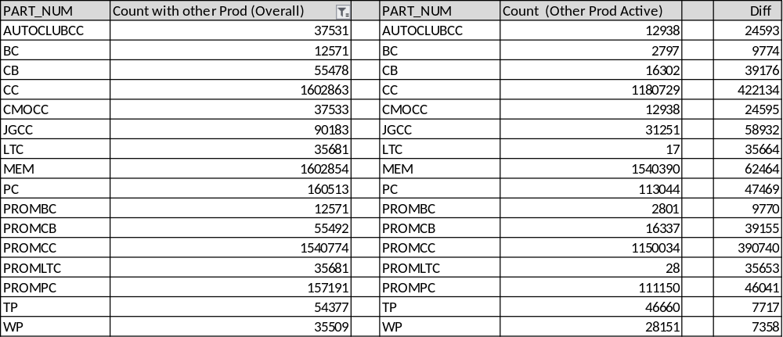

EIM Mapping to Prune table
In order to delete data by considering ‘Contact’ as a master entity, Siebel EIM approach would be leveraged and it requires mapping between Base table & Interface (EIM) tables. This mapping would be used while inserting data into EIM tables.
In Siebel EIM framework, ‘CASCADE DELETE’ option will be used at appropriate table level and at rest of the deletion process, ‘EIM Delete’ will be used.

EIM mapping details for parent and dependent tables covered as part of this project is as below:
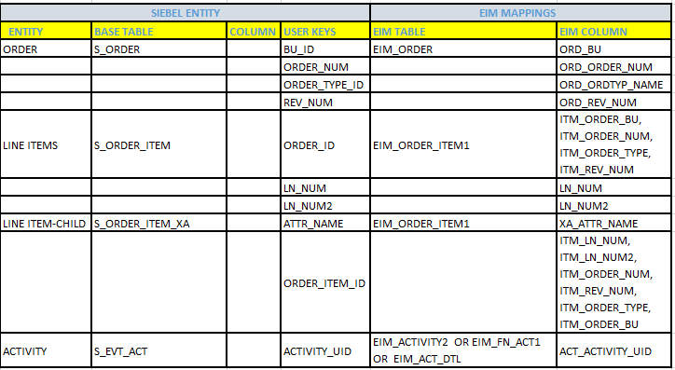

Attaching sample IFB file for reference –

[Siebel Interface Manager]
PROCESS = DELETE ORDERS
[DELETE ORDERS]
TYPE = DELETE
BATCH = &RANGE
TABLE = EIM_ORDER
DELETE EXACT=TRUE
CASCADE DELETE ONLY=TRUE
ONLY BASE TABLES =S_ORDER

Also, below table provides GMS table level statistics with ‘Treatment’ (Truncation/Deletion) for reference –
TABLE_NAME | NUM_ROWS | BYTES (MB) | Treatment
S_WFA_STPRP_LOG | 736067367 | 121264 | Truncation
S_AUDIT_ITEM | 161314833 | 64393 | Truncation
S_ORDER_ITEM_XA | 259153233 | 52011 | Deletion
S_ASSET_XA | 133619133 | 23532 | Deletion
S_ORDER_ITEM | 32426850 | 22677 | Deletion
S_EVT_ACT | 14495640 | 15378 | Deletion
S_ASSET | 16575810 | 12598 | Deletion
S_AGREE_BNFT | 44254720 | 12278 | Deletion
CX_IRAS_LOG | 17818510 | 11262 | Truncation
CX_CAM_RESPONSE | 47794700 | 9113 | Truncation
S_ORDER | 11345670 | 8476 | Deletion
CX_IRASLOGREQ_X | 11269060 | 7789 | Truncation
S_ORG_EXT | 5688677 | 6746 | Deletion
S_ORDER_ITEM_OM | 32398610 | 5703 | Deletion
S_VALDN_INST | 39377180 | 5497 | Truncation
S_EVT_MAIL | 1468917 | 5215 | Deletion
S_WFA_INSTP_LOG | 33106560 | 5106 | Truncation
S_SRC_PAYMENT | 8306403 | 4940 | Deletion
CX_LOG_ERROR | 13376750 | 4553 | Truncation
S_ORDER_ITEM_X | 23740760 | 3892 | Deletion
S_ORDER_X | 11338390 | 3480 | Deletion
S_CONTACT | 3526430 | 3071 | Deletion
S_CON_ADDR | 15229270 | 2767 | Deletion
S_ACT_EMP | 12743030 | 2493 | Deletion
S_ASSET_X | 15955850 | 2444 | Deletion
S_SRV_REQ | 3309820 | 2370 | Deletion
S_ORDER_BU | 16733980 | 2217 | Deletion
S_EVT_ACT_X | 12625060 | 2182 | Deletion
S_ORDER_ITM_PRI | 15666520 | 1995 | Deletion
S_ASSET_BU | 16196170 | 1939 | Deletion
S_CAMP_CON | 5739417 | 1833 | Deletion
S_AGREE_ITEM | 6468583 | 1800 | Deletion
S_ORDER_POSTN | 11511360 | 1761 | Deletion
S_ENTLMNT | 9396127 | 1681 | Deletion
S_ACT_CONTACT | 12709221 | 1500 | Deletion
S_ORG_EXT_X | 5665947 | 1411 | Deletion
S_CONTACT_FNX | 3474657 | 1408 | Deletion
S_ASSET_OM | 12348010 | 1345 | Deletion
S_SRV_REQ1_FNX | 3305003 | 1287 | Deletion
S_PARTY | 9220627 | 1285 | Deletion
S_ASSET_EMP | 12152400 | 1282 | Deletion
S_SRM_DATA | 422014 | 1223 | Truncation
S_ADDR_PER | 4332917 | 1222 | Deletion
S_ORDER_DTL | 7501527 | 1158 | Deletion
S_ORDER_TNTX | 7485260 | 1158 | Deletion
S_SRV_REQ_X | 3259830 | 1156 | Deletion
S_AGREE_POSTN | 7704100 | 1016 | Deletion
S_SRC_PAY_POSTN | 9222887 | 998 | Deletion
S_ACCNT_POSTN | 5694713 | 994 | Deletion
S_DOC_AGREE_BU | 7703557 | 972 | Deletion
S_CONTACT_X | 3494443 | 897 | Deletion
S_ORG_BU | 5691277 | 883 | Deletion
S_CAL_REPT_EVT | 8000127 | 880 | Deletion
S_EVT_ACT_FNX | 4576617 | 874 | Deletion
S_EVT_ACT_CAL | 8218267 | 824 | Deletion
S_SRM_REQUEST | 346571 | 791 | Deletion
S_CONTACT_IMPT | 4005733 | 784 | Deletion
S_ORD_ITM_LOYX | 6177810 | 757 | Deletion
S_PARTY_PER | 6360530 | 747 | Deletion
S_SRV_REQ2_FNX | 3285180 | 716 | Deletion
S_AGREE_TERMS | 5229283 | 699 | Deletion
S_SRC_PAY_FRAUD | 5584407 | 624 | Deletion
S_SRV_ACT | 5863720 | 610 | Deletion
S_SRV_REQ_BU | 3316277 | 556 | Deletion
S_ASSET_CON | 2922370 | 536 | Deletion
S_POSTN_CON | 3528087 | 531 | Deletion
S_ASSET_POSTN | 3851417 | 520 | Deletion
S_ESCL_LOG | 2147770 | 517 | Truncation
S_ORDER_FMX | 3271157 | 503 | Deletion
S_SRV_REQ3_FNX | 3311803 | 487 | Deletion
S_EVT_CAL | 4838340 | 483 | Deletion
S_CONTACT_BU | 3531817 | 478 | Deletion
S_EVT_MKTG | 4837483 | 472 | Deletion
S_EVT_ACT_FSX | 4514270 | 472 | Deletion
S_CONTACT_ATX | 3460317 | 368 | Deletion
S_ADDR_PER_X | 2048377 | 329 | Deletion
S_ADDR_PER_WM | 3274563 | 324 | Deletion
S_WFA_DATA | 197967 | 320 | Truncate
S_WFR_PROC_FLOW | 677390 | 315 | Truncation
S_WFA_INST_LOG | 1377077 | 277 | Truncation
S_ACCNT_AGR_CUT | 2447490 | 251 | Deletion
S_WFA_INST_PROP | 165449 | 245 | Truncation
CX_OMC_PROC | 1376827 | 237 | Deletion
S_WFR_STP | 475496 | 200 | Deletion
S_NOTE_ACCNT | 982349 | 199 | Deletion
S_DOC_ORDER | 869740 | 186 | Deletion
S_ACCNT_ATT | 862576 | 183 | Deletion
S_CONTACT_TNTX | 796643 | 177 | Deletion
S_WFR_PROC_PROP | 696438 | 176 | Truncation
CX_BULK_UPLOAD | 346177 | 171 | Deletion
S_ORG_EXT_LSX | 893822 | 161 | Deletion
S_ESCL_REQ | 146778 | 129 | Truncation

PL/SQL script to Truncate tables
- To truncate log tables, PL/SQL script gets executed and it will read ‘Configuration’ file to read criteria for the respective table (if any).
- Below attached table contains list of tables considered for ‘truncation’ –

Table Name
CX_IRAS_LOG
CX_CAM_RESPONSE
CX_IRASLOGREQ_X
CX_LOG_ERROR
S_AUDIT_ITEM
S_WFA_INSTANCE
S_WFA_INST_PROP
S_WFA_INSTP_LOG
S_WFA_STPRP_LOG
S_WFA_INST_LOG
S_ESCL_REQ
S_ESCL_LOG
S_SRM_DATA
- Exit criteria in Jenkins would be setup in such a way that subsequent steps would be taken up only when current step is executed successfully.
- PL/SQL jobs to truncate will be scheduled in parallel where no dependencies are found.
- On successful execution, base table data gets truncated.

EIM Job Execution to Prune tables
- Before executing the EIM job, ‘Enterprise Integration Manager’ component should be up and running in the TEST environment
- EIM job will be executed and this will be scheduled via Jenkins.
- Supporting IFB and control files will be placed at defined path.
- Exit criteria in Jenkins would be setup in such a way that subsequent steps would be taken up only when current step is executed successfully.
- EIM jobs to truncate will be scheduled in parallel where no dependencies are found.
- On successful execution, base table data gets deleted.

Gather DB Statistics
- After execution of the EIM job, need to gather DB statistics.

Verify Pruned tables
Upon successful execution of the ‘Data Prune’ job, process will be automated to verify if the data from all target tables got deleted successfully or not using a validation job though jenkins.

Post Pruning Setup
- Enable database triggers
- Drop temp tables

GMS Data Masking

Requirement Summary
Today in NRMA GMS system, whenever production instance is cloned to test instance, all key information about NRMA’s customers will also get exposed in the test system. This leads to data security issues.
NRMA wishes to build an automated and configurable framework to clone data to non-production environments, which fields are de-identified, whilst maintaining the data integrity. The primary objective of this engagement is to ensure that production data, particularly PII and other sensitive data is not present outside of the production environment.

Proposed Solution
Innovacx proposes below approach to sanitize the sensitive information while copying the high volume data in Siebel Production database: -

2.2.2.1 Clone Prod DB
- Refer section 2.1.2.1

2.2.2.2 Identify Siebel attributes to be masked
Below attributes should be masked after copying from Production database instance –
Table Name | Masking Attribute
S_ORG_EXT | MAIN_EMAIL_ADDR
S_ORG_EXT | MAIN_PH_NUM
S_ORG_EXT | NAME
S_ORG_EXT | LOC
S_ORG_EXT | X_LEGAL_ENTITY_NAME
S_ORG_EXT | ANS_SRVC_PH_NUM
S_ORG_EXT | OU_NUM
S_ORG_EXT | X_EMAIL_UNSUBCRIBE_DT
S_CONTACT | FST_NAME
S_CONTACT | LAST_NAME
S_CONTACT | HOME_PH_NUM
S_CONTACT | WORK_PH_NUM
S_CONTACT | BIRTH_DT
S_CONTACT | MID_NAME
S_CONTACT | CELL_PH_NUM
S_CONTACT | ASST_PH_NUM
S_CONTACT | EMAIL_ADDR
S_CONTACT | ALT_EMAIL_ADDR
S_CONTACT | FAX_PH_NUM
S_CONTACT | X_DRV_LIC_CLS
S_CONTACT | CSN
S_ADDR_PER | ADDR
S_ADDR_PER | ADDR_LINE_2
S_ADDR_PER | X_ADDR_ROLE
S_AGREE_BNFT | NAME
S_ASSET | NAME
S_ASSET | X_TRANS_PHONE
S_ASSET_X | X_NOTIFICATION_EMAIL
S_ASSET_X | ATTRIB_37
S_ASSET_X | X_VEH_DEPOT_PH
S_ASSET_X | X_AUTH_CON_NAME
S_ASSET_X | X_AUTH_CON_PH
S_ASSET_X | X_AUTH_CON_EMAIL
S_ASSET_X | X_VEH_WRTY_PH
S_ASSET_X | X_ENGINE_WRTY_PH
S_ASSET_X | X_BAT_WRTY_PH
S_ASSET_X | X_GEAR_WRTY_PH
S_CONTACT_ATX | DRIVER_LICENSE
S_CONTACT_X | ATTRIB_09
S_CONTACT_X | ATTRIB_10
S_CONTACT_X | ATTRIB_43
S_CONTACT_X | ATTRIB_36
S_CONTACT_X | ATTRIB_02
S_CONTACT_X | ATTRIB_41
S_EVT_ACT | CREATOR_LOGIN
S_EVT_ACT_FNX | TLR_ANONYMS_NAME
S_EVT_ACT | CALLER_NAME
S_EVT_ACT | X_NEWCONTACT_NAME
S_EVT_ACT_FNX | EXT_SYS_TXN_IDEN
S_EVT_ACT | X_OLD_MEM_CARD
S_ORDER | X_OMC_CAMP_NAME
S_ORDER_X | ATTRIB_39
S_ORG_EXT_FNX | BRLOC_ATTRIB01
S_ORG_EXT_FNX | TECH_IMP_CD
S_ORG_EXT_FNX | NPI_NUM
S_PTY_PAY_PRFL | PROFILE_NAME
S_PTY_PAY_PRFL | X_SEC_PAY_TOKEN
S_PTY_PAY_PRFL | ACCNT_BANK_NAME
S_PTY_PAY_PRFL | PAY_ACCNT_NUM
S_PTY_PAY_PRFL | ACCNT_BANK_BRANCH
S_PTY_PAY_PRFL | DESC_TEXT
S_PTY_PAY_PRFL | X_ACCNT_NAME
S_SRC | NAME
S_SRC_PAYMENT | X_EXT_PAY_REF
S_SRV_REQ | X_DRIVER_EMAIL
S_SRV_REQ | X_DRIVER_PHONE
S_SRV_REQ | ALT_CON_EMAIL
S_SRV_REQ | X_ADDR_LINE_2
S_SRV_REQ | X_REQUESTOR_FULL_NAME
S_SRV_REQ | X_NRMA_REQ_HOME_PHONE
S_SRV_REQ | X_BSB
S_SRV_REQ | X_INTER_CLUB_MEM_NUM
S_SRV_REQ | X_INSTATE_CLUB_NAME
S_SRV_REQ | X_NRMA_REQ_EMAIL
S_SRV_REQ | X_NRMA_EMAIL_PREFERRED
S_SRV_REQ_X | ATTRIB_03
S_SRV_REQ_X | ATTRIB_43
S_SRV_REQ_X | ATTRIB_42

2.2.2.3 Sanitize Sensitive Information
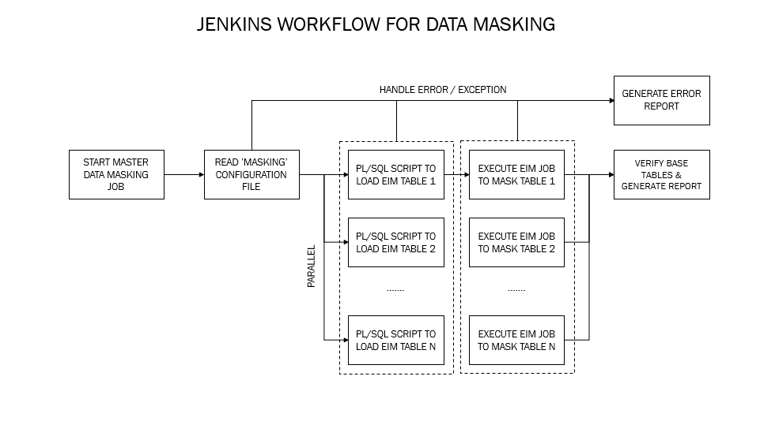

‘Configuration File’ to select tables to mask
NRMA wishes to build a ‘data de-identification’ job that can be executed on any target test DB instance by passing dynamic criteria values. In order to achieve this, solution includes ‘Configuration File’ that will be passed as an input file while executing the PL/SQL scripts.
In this ‘Configuration File’, user can specify the table name, Super Set and subset with fields that need to be considered while masking the attributes.
Data_Masking_Config_File.txt
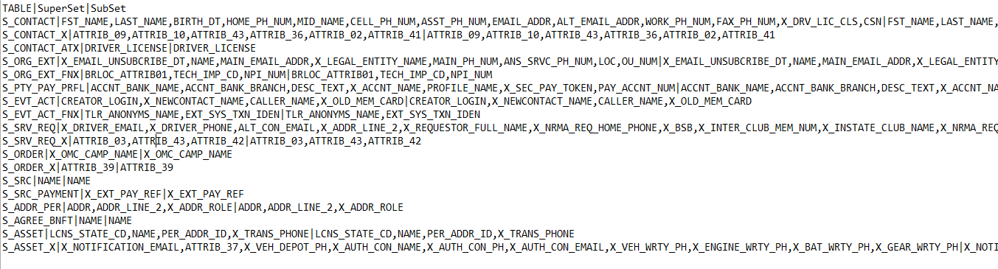

in section 2.2.2.2 contains fields and masking rules that need to be masked as part of this engagement.

Data Masking Logic
Below masking logic will be followed to mask the ‘string’ and ‘numeric values’ in all identified tables. Also, this masking logic will be common across all the systems: -
TRANSLATE (<column name>, <string to replace>, <replacement string>)
on the ‘DATA_PRUNING_USER’ schema, ‘DATA_MASKING_TRANSLATE’ table will be created to store ‘String to replace’ and ‘Replacement string ‘. This can be referenced from subsequent PL/SQL script used to mask the attributes.
CREATE TABLE DATA_MASKING_TRANSLATE (
String_to _replace (60),
Replacement_string varchar (60)
);
INSERT INTO DATA_MASKING_TRANSLATE (String_to _replace, Replacement_string)
VALUES (‘abcdefghijklmnopqrstuvwxyzABCDEFGHIJKLMNOPQRSTUVWXYZ0123456789’,
‘zabycxdwevfugthsirjqkplonmZABYCXDWEVFUGTHSIRJQKPLONM2014365897’);

EIM Mapping to mask attributes
Data will be masked on the tables mentioned in ‘Configuration File’ and this data would be selected based on the criteria defined in the same ‘Configuration File’.
In order to sanitize the data, Siebel EIM approach would be leveraged and it requires mapping of Base table & Interface (EIM) tables. This mapping would be used while inserting data into EIM tables.

For reference, attaching the sample IFB file for data masking –

[Siebel Interface Manager]

PROCESS = UPDATE CONTACTS

[UPDATE CONTACTS]

TYPE = INSERT
BATCH = &RANGE
TABLE = EIM_CONTACT

ONLY BASE TABLES=S_CONTACT

ONLY BASE COLUMNS=S_CONTACT.BU_ID,\
S_CONTACT.PERSON_UID,\
S_CONTACT.PRIV_FLG,\
S_CONTACT.FST_NAME,\
S_CONTACT.LAST_NAME,\
S_CONTACT.HOME_PH_NUM,\
S_CONTACT.WORK_PH_NUM,\
S_CONTACT.BIRTH_DT,\
S_CONTACT.MID_NAME,\
S_CONTACT.CELL_PH_NUM,\
S_CONTACT.ASST_PH_NUM,\
S_CONTACT.EMAIL_ADDR,\
S_CONTACT.ALT_EMAIL_ADDR,\
S_CONTACT.FAX_PH_NUM,\
S_CONTACT.SUPPRESS_EMAIL_FLG,\
S_CONTACT.CSN

UPDATE ROWS = S_CONTACT, TRUE
INSERT ROWS = S_CONTACT, FALSE

Insert Masking Data into EIM tables
In order to mask Siebel attributes dynamically, PL/SQL procedures will be authored to insert data into EIM tables for tables, by reading ‘Configuration File’ placed at a defined on the target test instance.
The EIM Columns will have the Masked data (String to String and Number to Number) in EIM table. Once EIM job is executed the masked data will be updated in Siebel base tables.
Also, PL/SQL procedures will be scheduled via ‘Jenkins’ to automate the process.

EIM execution to Mask Attributes
- Before executing the EIM job, ‘Enterprise Integration Manager’ component should be up and running in the TEST environment
- EIM job will be executed for base tables (in parallel) and this will be scheduled via ‘Jenkins’.
- Supporting IFB and control files will be placed at defined path.
- On successful execution, base table data gets sanitized by getting replaced with dummy values.

Verify Masked attributes
Upon successful execution of the ‘Data Masking’ job, process will be automated to verify if the data from all target tables got updated(masked) successfully or not through validation job though jenkins.

Post Masking Step
- After successful execution of the masking job, drop table - DATA_MASKING_TRANSLATE.

Truncate Interface Table
- After successful execution of EIM jobs for Data Pruning & Masking, EIM table should be cleared.

Assumptions
- NRMA’s storage capacity of each target test instance is same as prod instance today. And in today’s world also, when we move data from Prod into any target test, it is full prod copy that goes into test. Hence we do not have any issue with regards to storage capacity in Test environments.

4.1 Table of Files and File path

Open and Closed Issues

Add open issues that you identify while writing or reviewing this document to the open issues section. As you resolve issues, move them to the closed issues section and keep the issue ID the same. Include an explanation of the resolution.
When this work product is complete, any open issues should be transferred to the project- or process-level Issue Log (Manage focus area) and managed using a project level Issue Form (Manage focus area). In addition, the open items should remain in the open issues section of this work product, but flagged in the resolution column as being transferred.

5.1 Open Issues

5.2 Closed Issues

6.Appendix

6.1 Appendix 1

6.2 Appendix 2

